Giving Tuesday Toolkit

Giving Levels 2
Homelessness 3
Women’s health 5
Veterans 7
Families 8

Giving Levels

Donations will be doubled thanks to the incredible generosity of our Board of Directors, 100% of whom contributed to make this match possible!

$25+$25=$50
$50+$50=$100
$100+$100=$200

Amount | Vets | Women | Families | General Homelessness 1 | General Homelessness 2
$25 | One baking kit for a Veteran graduating from our Culinary Arts Training Program | Outreach materials to recruit women for screening aboard our ScanVan mobile mammography clinic | Kitchen supplies for parents in recovery from addiction in our En Casa family program. | 8 meals | A hot meal for 8 homeless men at our Third Street Shelter in the East Village
$50 | Metro cards for 10 Veterans to attend interviews | Groceries for one week for a mother and her children in our En Casa program for families | One week of groceries for a family in our En Casa program. | 16 meals | A hot meal for 16 homeless women at our New Providence Shelter near Grand Central.
$100 | A communications workshop to prepare resumes and teach interview skills | Five meetings with a counselor to support a mother in recovery | All bed linens for a family moving into an apartment in our En Casa program. | 32 meals | Stocks our mobile medical van with over the counter medicines for 2 weeks.
$1,000 | One-on-one job placement preparation and follow-up during employment | 5 ScanVan visits with follow up for breast cancer early detection | All bedroom furnishings for a family in our En Casa program. | 320 meals | Furnishes the bedroom for an individual moving from our shelter into his or her own apartment.

Homelessness

Challenge:
Only 42% of homeless men and women in shelters were able to move into housing last year largely due to the shortage of affordable and appropriate housing.

Solution:
Our community based apartments (or scattered-site housing) provide permanent homes for men and women ready to leave the shelter system and live in the community. The residents in our community based apartments have coped with mental illness, addiction and homelessness. Residents have access to the recovery, employment or other support services they need as they reintegrate into their community.

Impact:
In one year, 456 men and women moved from Project Renewal’s shelters into permanent homes; 94% are still housed after 6 months. In our program, men and women who are often denied housing because of their histories of addiction or criminal records are given a second chance and a home.

Photos

http://www.flickr.com/photos/projectrenewal/8284713580/in/set-72157629841067611
http://www.flickr.com/photos/projectrenewal/8094663732/in/set-72157631614125161

Harry Dickerson Photo:
http://www.flickr.com/photos/projectrenewal/8023470353/in/set-72157631614125161

Harry Dickerson Quote: “I was released from prison after eight and a half years, but it’s not how you start out at the gate, it’s how you finish.”-harry

Cedric Odum Quote:

“My addiction led me into homelessness in Manhattan. Out of my 51 years of life, I was in addicted for 33 years.

During my addiction, my mother passed away in 2010, and my life got even more crazy than what I was living. I had a 21 year old son. He knew the things that I was doing.

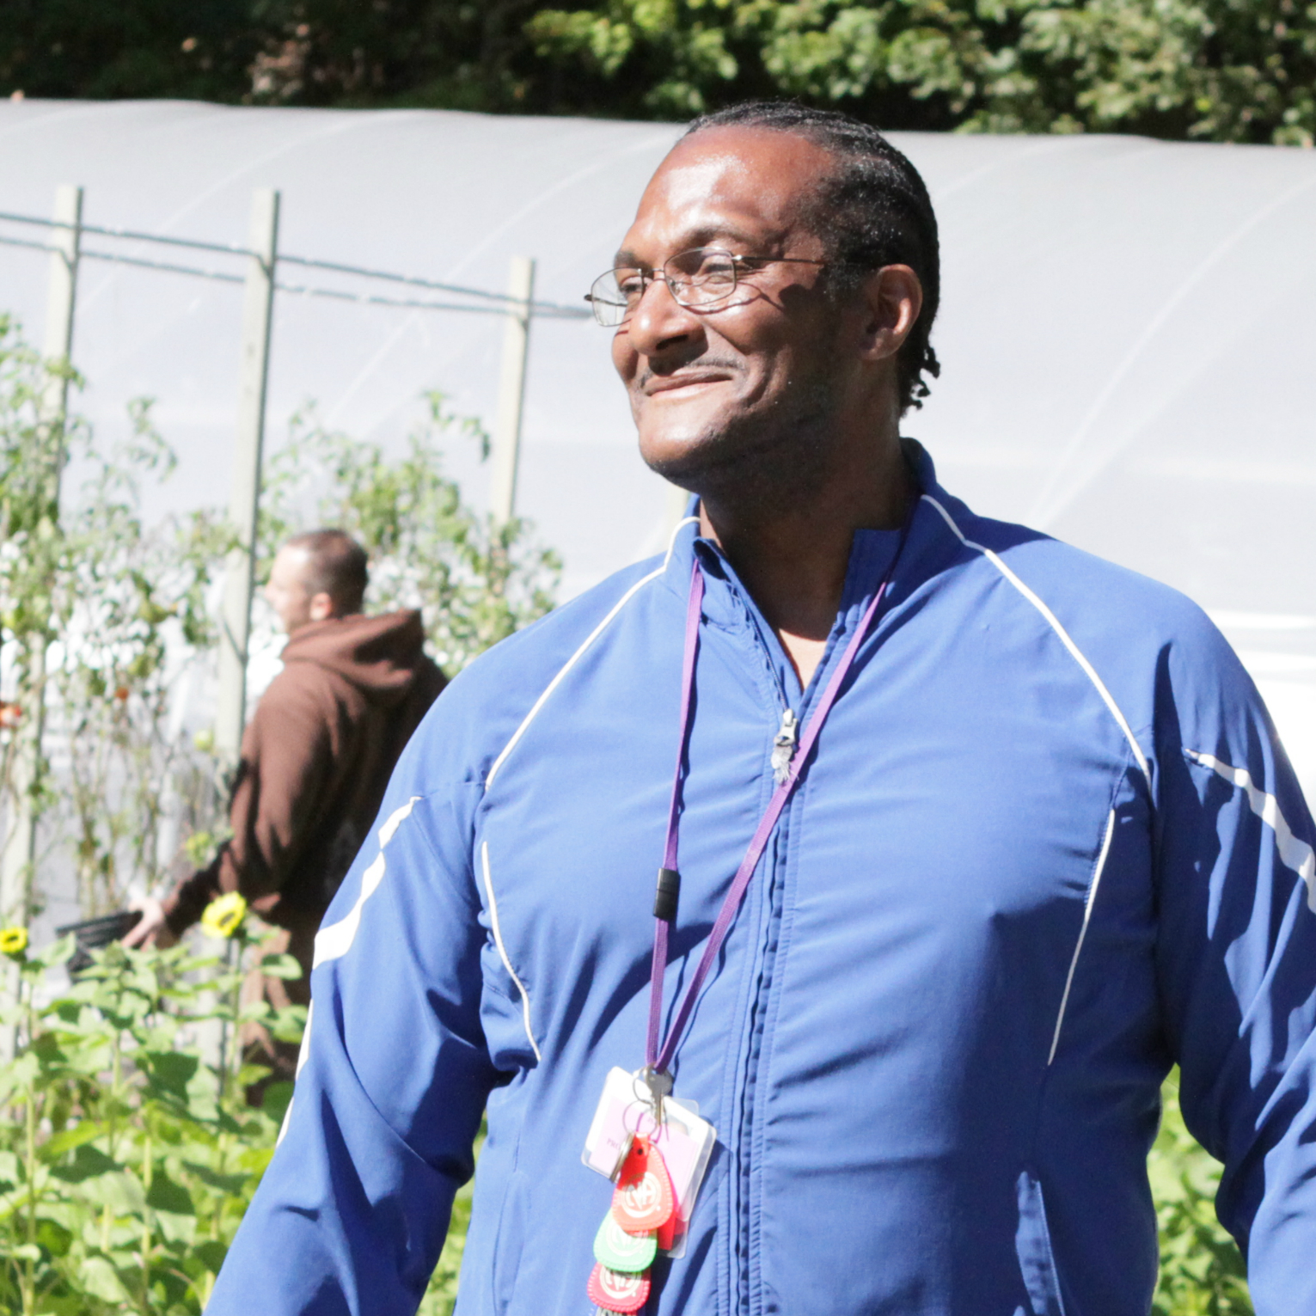
Actually, I’m just blessed to be here because really I should be dead. He lost his mother and he lost his grandmother, which is my mother. He got a tattoo of his mother and my mother on him. He came and he found me one day and he cried to me asking me to please stop doing what you’re doing. I knew what I was doing was bad, you know, my life was just terrible. What touched me was that he said he didn’t want to put a tattoo of me on his body.

Me and him cried together and it just made me surrender. It just made me feel like I need to save my life and I need to be there for him. That happened February 3rd of this year, 2013. That Monday morning February 4th, I actually turned myself into the detox at Project Renewal’s Third Street Shelter.

I got lost for 33 years to addiction and I’m just glad I got the opportunity to save my life here at Renewal Farm. I feel something like the comeback kid right now.”

Women’s health

Challenge:
Last year, 4 out of every 10 uninsured women did not receive a mammogram.

Solution:
ScanVan is the country's first mobile mammography and radiology clinic for homeless and uninsured adults. ScanVan provides clinical breast exams, mammograms, tuberculosis (TB) tests, and health education to homeless and low-income men and women. We visit homeless shelters, drop-in centers, and street-side locations in all five boroughs of New York City.

Impact:
In one year, ScanVan screened 4,479 low-income women for breast cancer regardless of insurance or legal status. We detected breast cancer in 12 patients and ensured follow-up care for every one of them.

Photos:
http://www.flickr.com/photos/projectrenewal/8284732108/in/set-72157629953658862
http://www.flickr.com/photos/projectrenewal/8283667779/in/set-72157629953658862
http://www.flickr.com/photos/projectrenewal/7309732668/in/set-72157629986779714

Beverly Houston Story:
https://projectrenewal-test.squarespace.com/project-renewal-client-stories/2013/11/1/beverly-houston

Beverly Houston Quote:
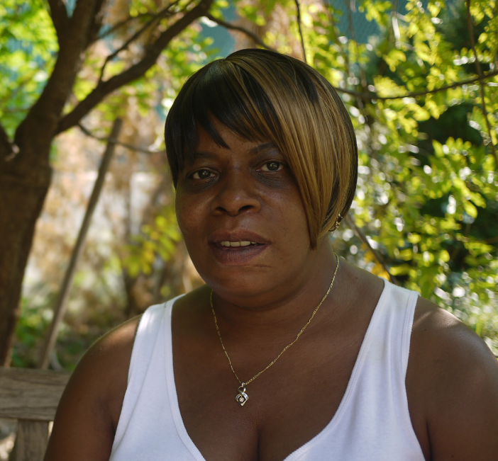
“I feel totally different. I feel good about myself and about my life—a complete turnaround.”-Beverly

Health-
“I was working on my sobriety and health and housing issues. Ever since 2004, I’ve been clean. They helped me with that. They helped me with a psychiatrist. They gave me different referrals to go to different doctors, but it was for me to choose which one I wanted to go to. They make sure that you maintain whatever medication you’re taking. They help you keep your appointments with the doctor, with the Department of Social Services or Social Security, and if you don’t want to go by yourself, they’ll go with you. You don’t have to do it alone when you’re in Project Renewal. It’s hard enough, and when you know that you have somebody to help you, it’s so much better.” -Beverly

ScanVan video:
http://www.youtube.com/watch?v=CHjpqmYF9Uw
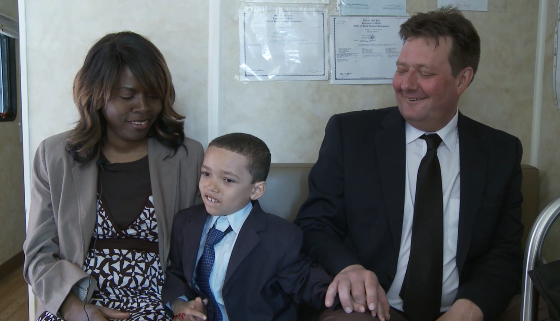

Maritzela McGreevy Quotes:

“I have a history of breast cancer in my family. I have an aunt who had it, an aunt who passed away from it. It runs rampant in my family, so it’s important I stay in the healthy zone.

I was breast feeding my son, and it started to become painful so I stopped. I had a pain on my left breast, but I didn’t really pay much attention to it. One day I said I better pay attention to it, I better get this free mammogram, because I didn’t have health insurance and I am glad that I did that because if I hadn’t I would have never found out that the lump I had was not a buildup of milk it was actually breast cancer. It breaks my heart when I see people with that disease, who are struggling, because I didn’t know, what a person would have to go through, at first I felt totally horrible , all I could think of was, ‘who would take care of [my son] David? What are they going to do?’

I am so thankful for life, because every day you have breath in your lungs is a good day!”

Veterans

Challenge:
Veterans are twice as likely as other Americans to become chronically homeless, and 76% of homeless veterans experience addiction or mental health problems.

Solution:
In 2012, we launched Veterans Employment Training Services (VETS) to help homeless men and women who have served our country get back on their feet and back in the workplace. VETS provides outreach, one-on-one support, job training and job placement to help homeless veterans find and keep jobs.

Impact:
The average wage of our newly employed veterans is $11.25 per hour – 55% above the minimum wage of $7.25.

Photos
http://www.flickr.com/photos/projectrenewal/7421397060/in/set-72157630239986886
https://projectrenewal-test.squarespace.com/vets/

Keith Ford Quote:

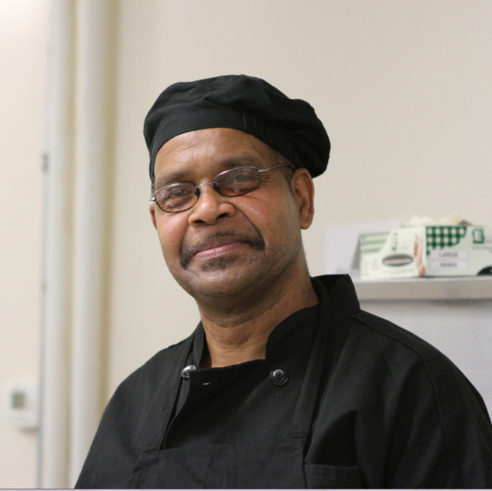
“I was released on honorable discharge because I hurt my knee on a down tree trunk in training down south. Being in the service was a family thing, everyone did it.

In the Culinary Arts Training Program, I learned culinary skills and it helped me develop something that I always liked. I worked my whole life doing different things, but I come from a family in culinary arts.

I don’t get a chance to cook [because I’m in the shelter]. I wish I did but up until I find an apartment and build some revenue from work I won’t. Samantha [Project Renewal Staff] is helping with that so I can get an apartment.”

It’s a good job. I enjoy it. I just want to keep on doing what I do best.”

Families

Challenge:
Over 20,000 homeless children sleep in city shelters. Many of their parents struggle with chronic addiction and mental illness.

Solution:
Our new supportive housing program reunites families where a parent has a history of substance abuse and supports them with on-site case management so they can stay together.

Impact:
In one year, 456 men and women moved from Project Renewal’s shelters into permanent homes; 94% are still housed after 6 months. By combining strategic partnerships with our track record of success in supportive housing for single adults we are setting up these reunited families for success.

Photos
http://www.flickr.com/photos/projectrenewal/9631118326/in/set-72157629862806710

https://www.facebook.com/photo.php?fbid=10151731151066154&set=a.167683781153.160227.32402371153&type=3&theater

Peter Quote:

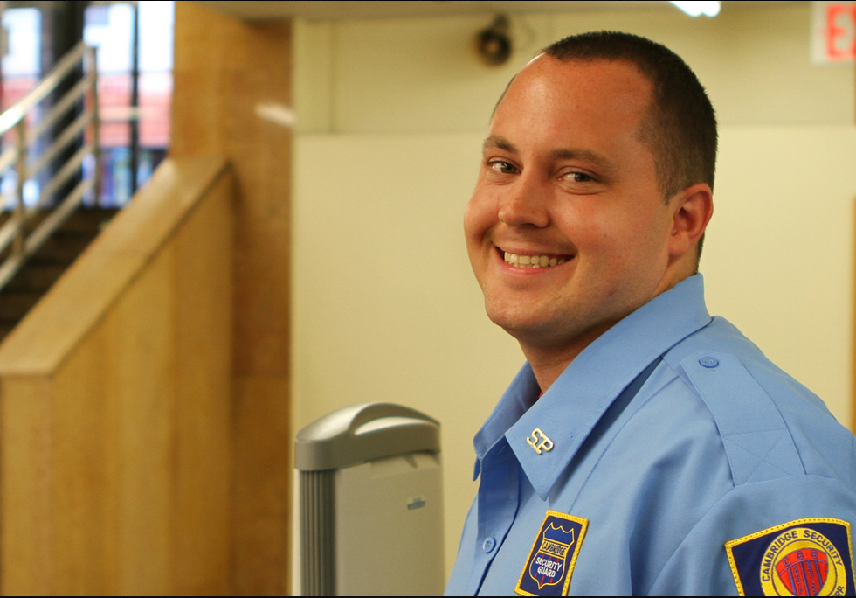
“I was homeless for 2 years before I came to Project Renewal and I was selling drugs. Then things went down the drain, I didn’t have money, my son was born, and I totally flipped. Instead of going to jail I went to Project Renewal. They believed in me that was really powerful for me.
I started to believe in myself. I haven’t missed a day of work yet. I go to my program every day. I went to my program this morning.
I feel like I'm a man now and I take care of my responsibilities now which I should have been doing. And I am a person that cares about other people and I am a father that cares. I'm gonna teach my son hockey.”

